AWS Data Analytic Platform for The City of Vancouver

# DAP Design and Implementation

**Introduction:**

The data set tracks service request calls that the customer initiates to the 3-1-1 Contact Centre for the City of Vancouver from 2022. These service requests have reference to till call types that place into action requests to the respective City of Vancouver departments, thereby entailing the provision of services to meet public needs. This information source contains specific records of the requests made and some of the information that is required involves the type of request, the time the request was made and the status of the request. Besides that, it has GPS coordinates, street name and number or the description of location, and locality of the service request or each case (incident).

Due to the large volume of records, data has been splitted to enhance its management as well as analysis. To the extent useful for historical purposes, a subset of service requests submitted between January 1, 2009, and December 31, 2021, are included in a dataset called “3-1-1 Service Requests 2009-2021.” This segmentation enables users to derive subsets from a given large data set and at the same time making the data more usable for a host of analytical purposes in areas like trends analysis, operational efficiency measurement and studies on resource utilization. The dataset is also useful to harmonize the location-based data with service request statuses as a roadmap to understanding how the community services are offered geographically and managed functionally for better planning or decision making on the advancement of the community services.

Q: Where and when there has been an increase in the volume of service requests, an analysis of available data must be made: how has the number of service requests to Vancouver Fire Rescue Services (VFRS) in the Downtown area changed over the period 2009-2024, and how does the pattern of service closure times and service request types vary over this period?

## 

## Descriptive Analysis

The data set offers wide information about customer-initiated service calls that the 3-1-1 Contact Centre in Vancouver receives, particularly the ones that involve engagement of city departments like VFRS. The data only contains information about requests filed in the year 2024, thus giving important information about the timing, type and location of service requirements. Every service request has an open field for time and date stamping which if used can infer frequency and distribution of such services. For example, the status of the request, in this case, being “Closed”, means that the Service request has been fulfilled.

The dataset also incorporates the precise locality service required, and the intersection or address of the service required together with the area in which the occurrence took place. For example, the Downtown area is identified as a large key area of service requests, which will allow for studying the demand for services in large city areas. Due to many records the data set has been divided into different periods, 3-1-1 service Requests 2009-2021 contains previous year requests as well. This segmentation allows for a comparison to previous years to identify trends and improve service analysis, resource distribution for city departments, and increasing response times in areas of high service demand such as Downtown. Towards that end, this type of data analysis can optimize service delivery and improve the delivery of municipal services in general.

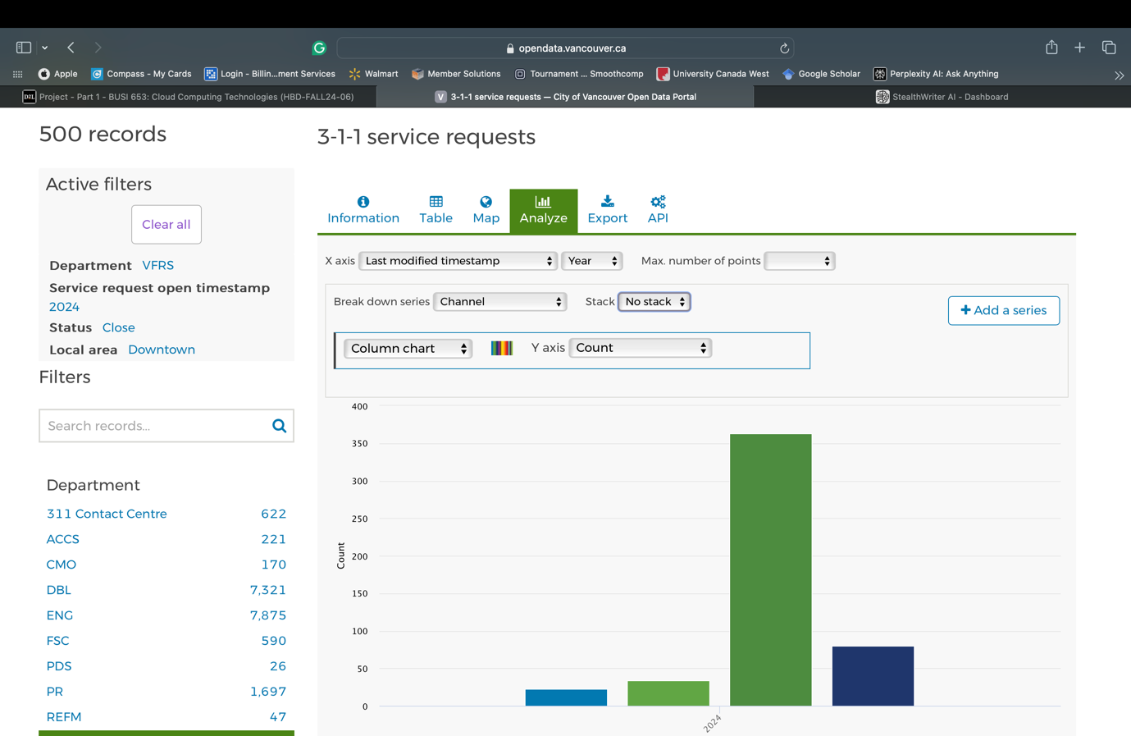

## Step 1: Data Ingestion

AWS S3 for storage design – Data is processed in different buckets according to the stage in which data is in.

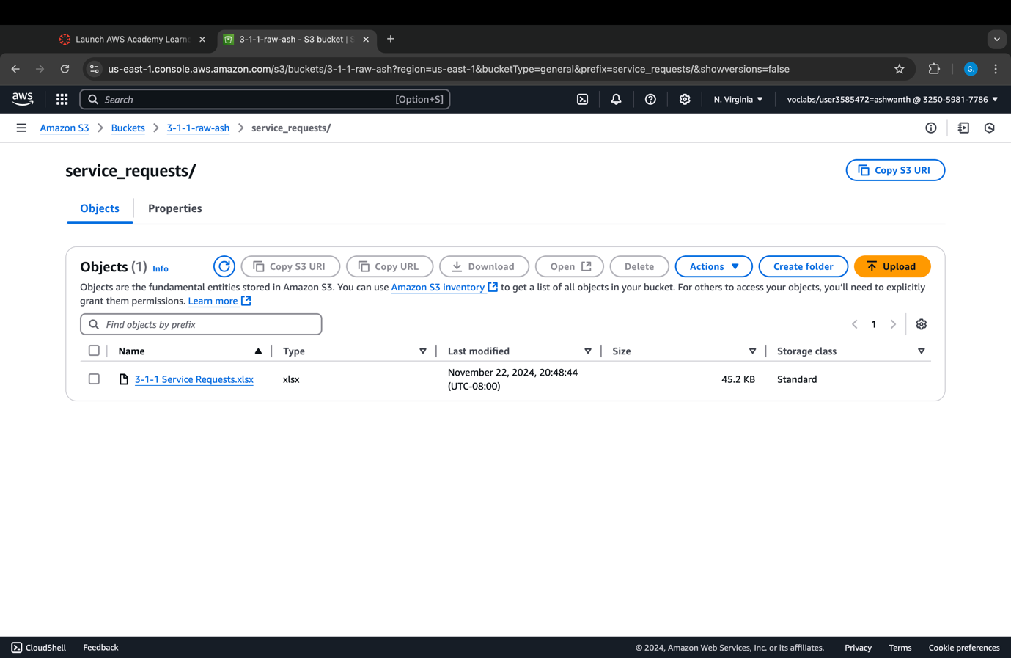

## Step 2: Data Profiling

AWS Glue Data Brew is used in this process. It is an easy-to-use data preparing service that can be used for cleaning and transforming raw data before analyzing them. It presents data analysis capabilities in the form of no code, visual programming interface.

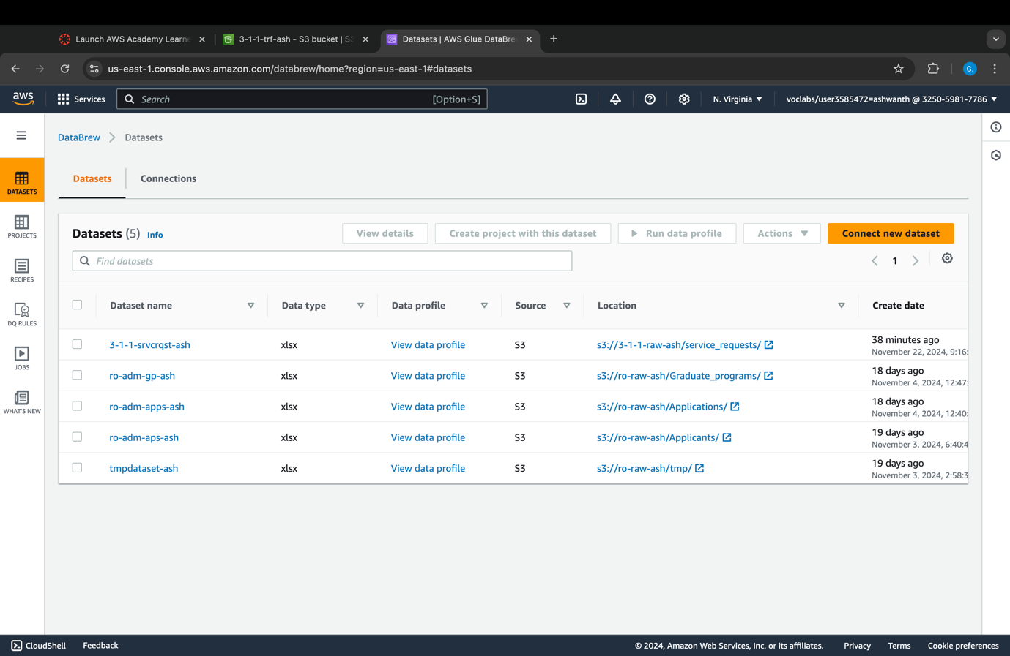

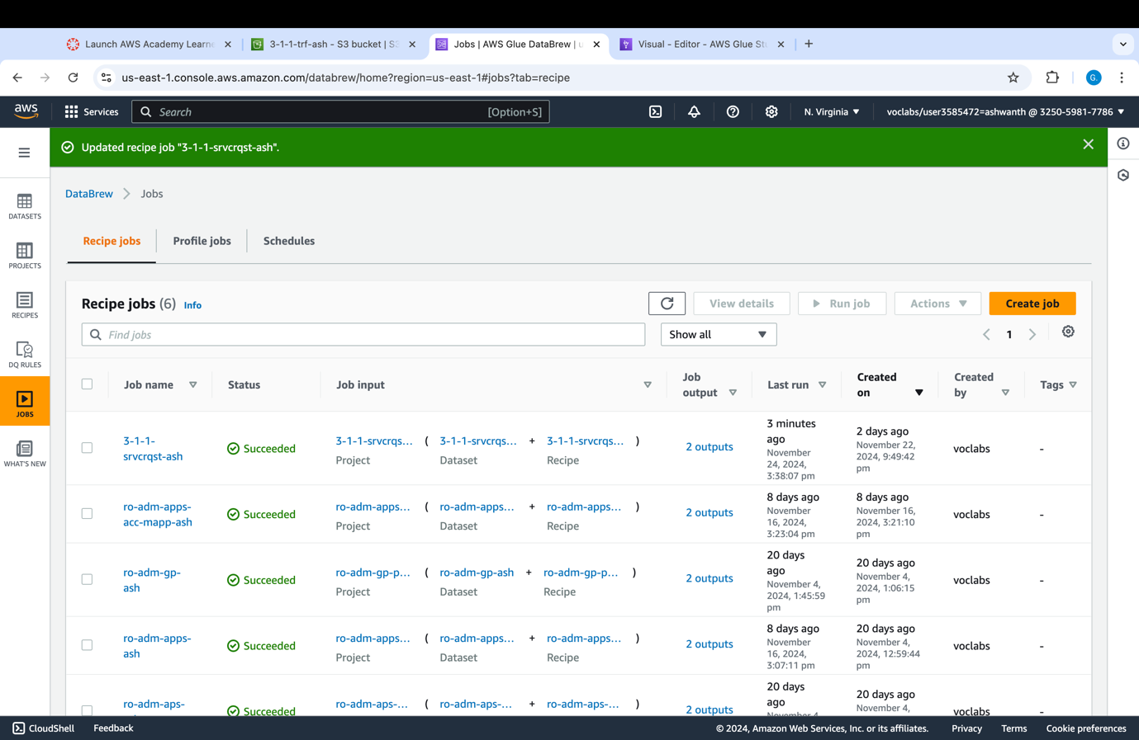

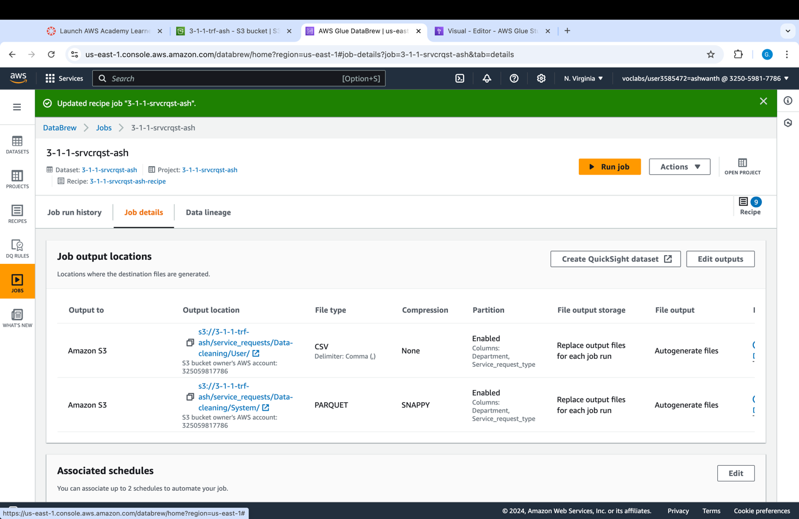

## Step 3: Data Cleaning

Filtering to delete noisy attributes and entries having the same meaning, same attributes but different values and incorrect vital statistics.

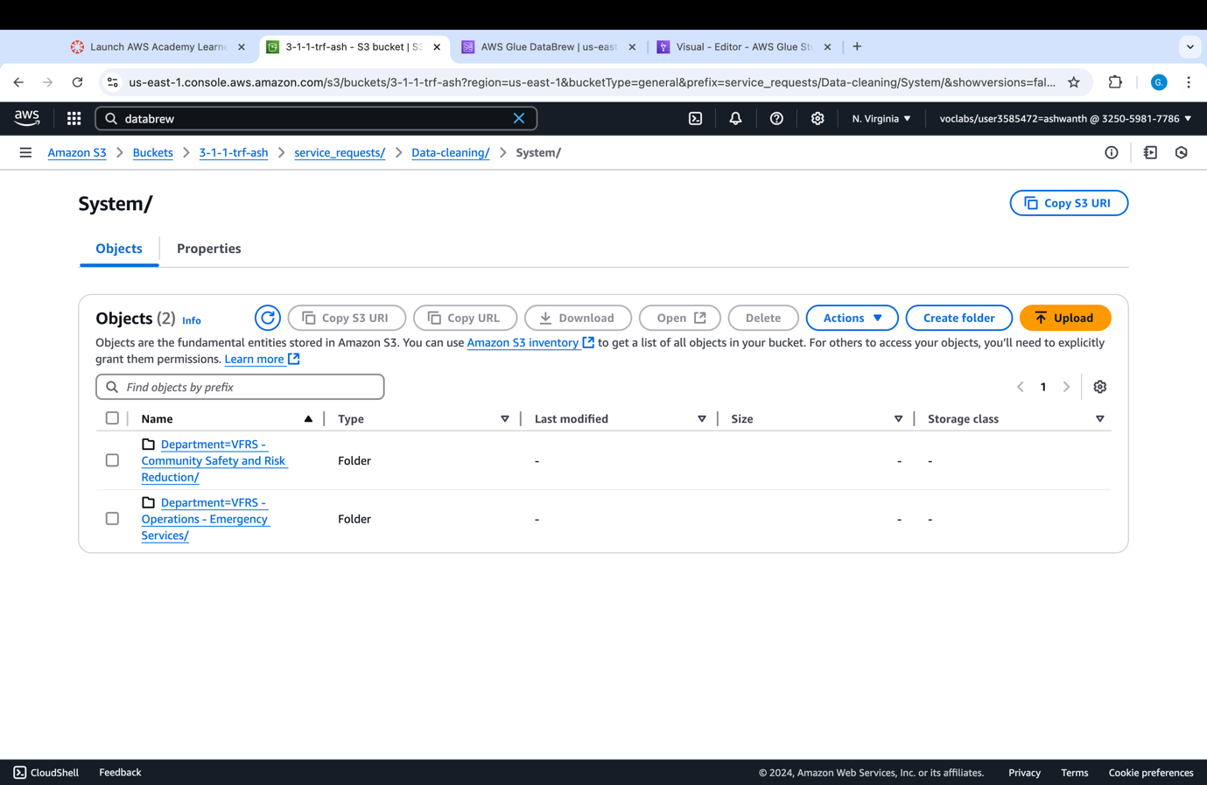

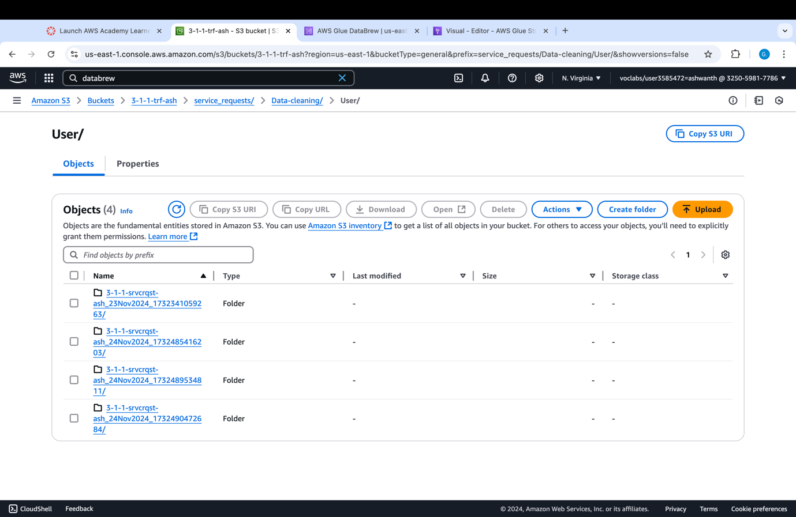

## Step 4: Data Pipeline Design

Another layer of transformation is included is the process that aggregates the data to enable us to understand service requests considering the local area field. By using an aggregation function such as count, the pipeline comes up with the overall count of the various service requests per given local area, thus helping understand how demand differs from one location to another.

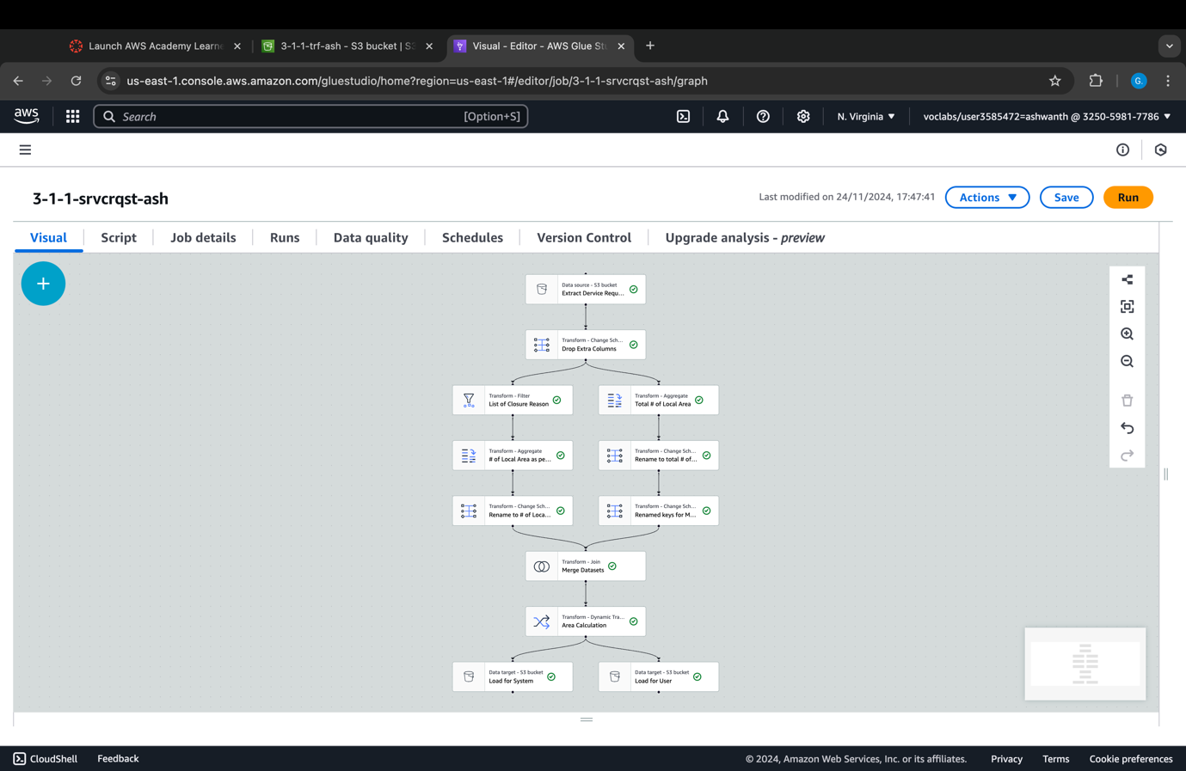

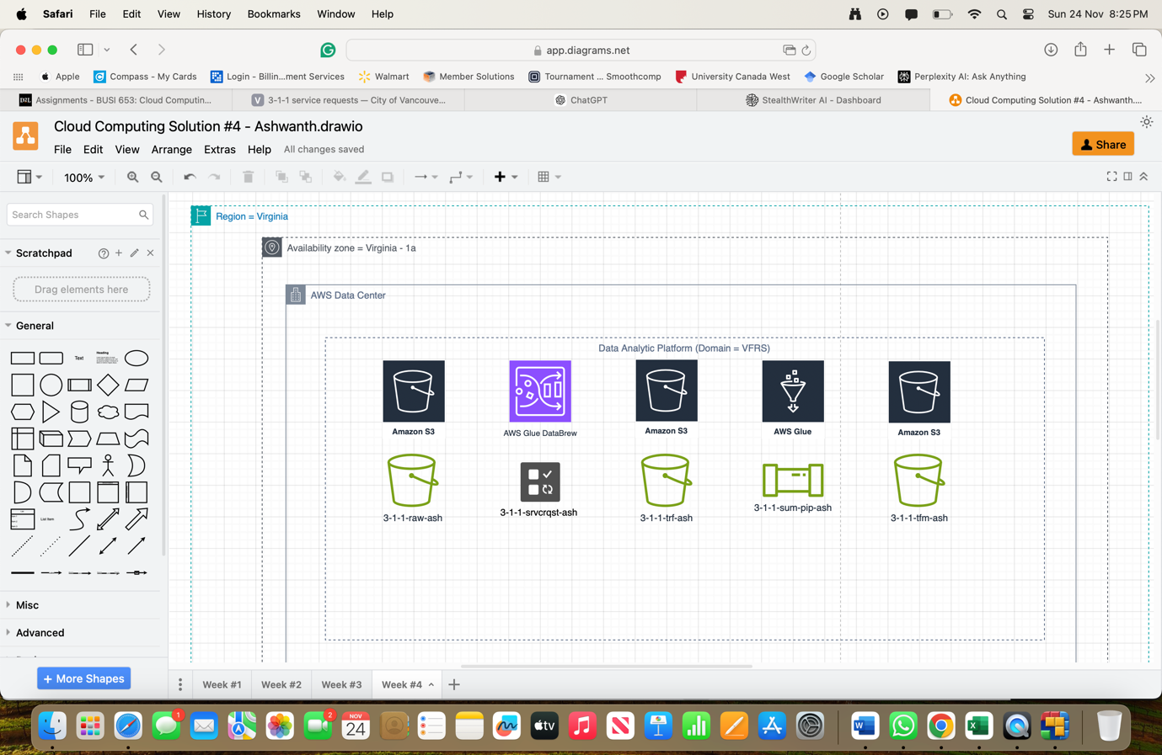

## Exploratory Analysis

The described dataset demands the intricate data pipeline that can handle the process of data gathering, processing and storage for the purpose of serving request data analysis. It starts with the extraction of data from the 3-1-1 Contact Centre where consumables’ calls are recorded including the time the call was made, type, location and state. The raw data is, therefore, moved and processed using ‘AWS Glue’ depending on scalability performance. For the data cleaning and transformation activity, AWS Glue DataBrew is used to transform format, delete twin rows, and filter off records. Moreover, the pipeline procures data that is then summed for further processing. There are two major aggregation fields: Local Area, and Status, where common count function was used to create high quality analysis. For the local area field, the data is then aggregated by neighborhood to arrive at total overall service requests from each locality. This assists in determining concerning areas that may require a lot of resources, like Downtown and so on.

Likewise, the status field is grouped for calculating the frequencies of the service requests in different statuses, for instance, open and closed. This gives a brief of operational efficiency and shows where the response rates are good or which ones require attention. For example, comparing the number of closed requests of Downtown to another area can indicate service inequality or high performance. By blending these aggregations, it is possible to obtain the pipe of GT’s demand, the efficiency of operations but also the perspective into how well GT serve cities. It permits decision-makers to allocate appropriate resources where they are probably most needed as well as to increase the efficiency of handling complaints, which in turn optimizes solutions in terms of service delivery.

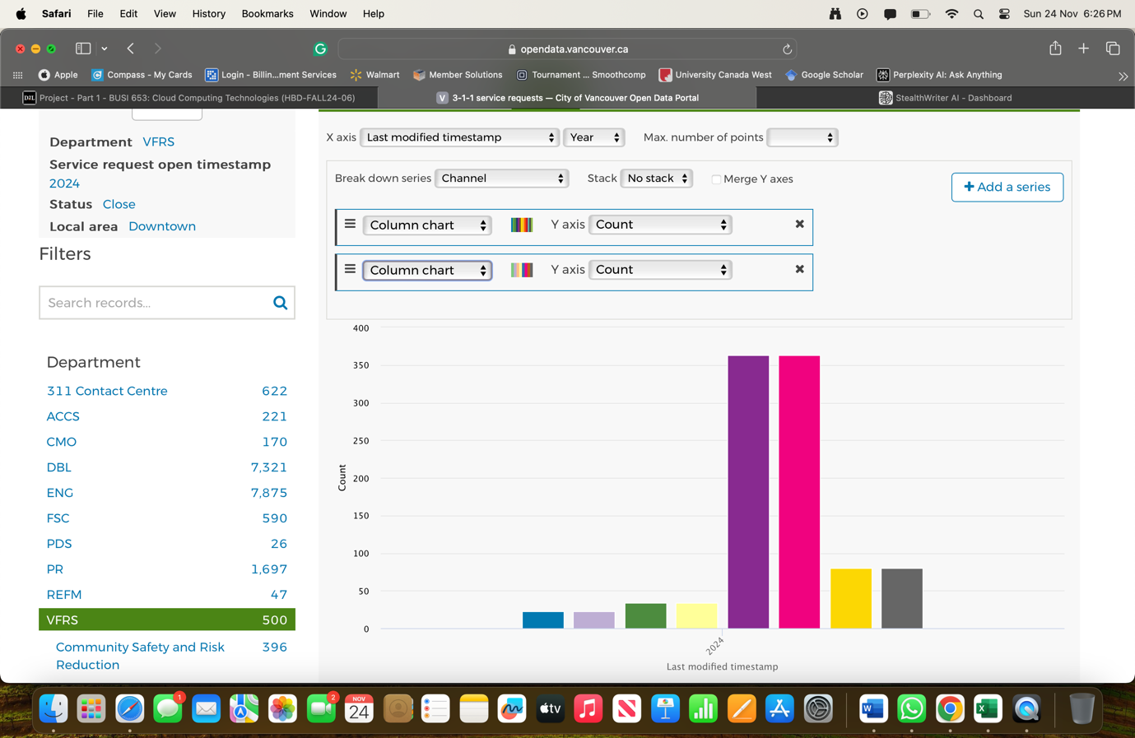

## Step 1: Data Ingestion

The steps would remain the same as the descriptive analytics part.

## Step 2: Data Profiling

The steps would remain the same as the descriptive analytics part.

## Step 3: Data Cleaning

The steps would remain the same as the descriptive analytics part.

## Step 4: Data Pipeline Design

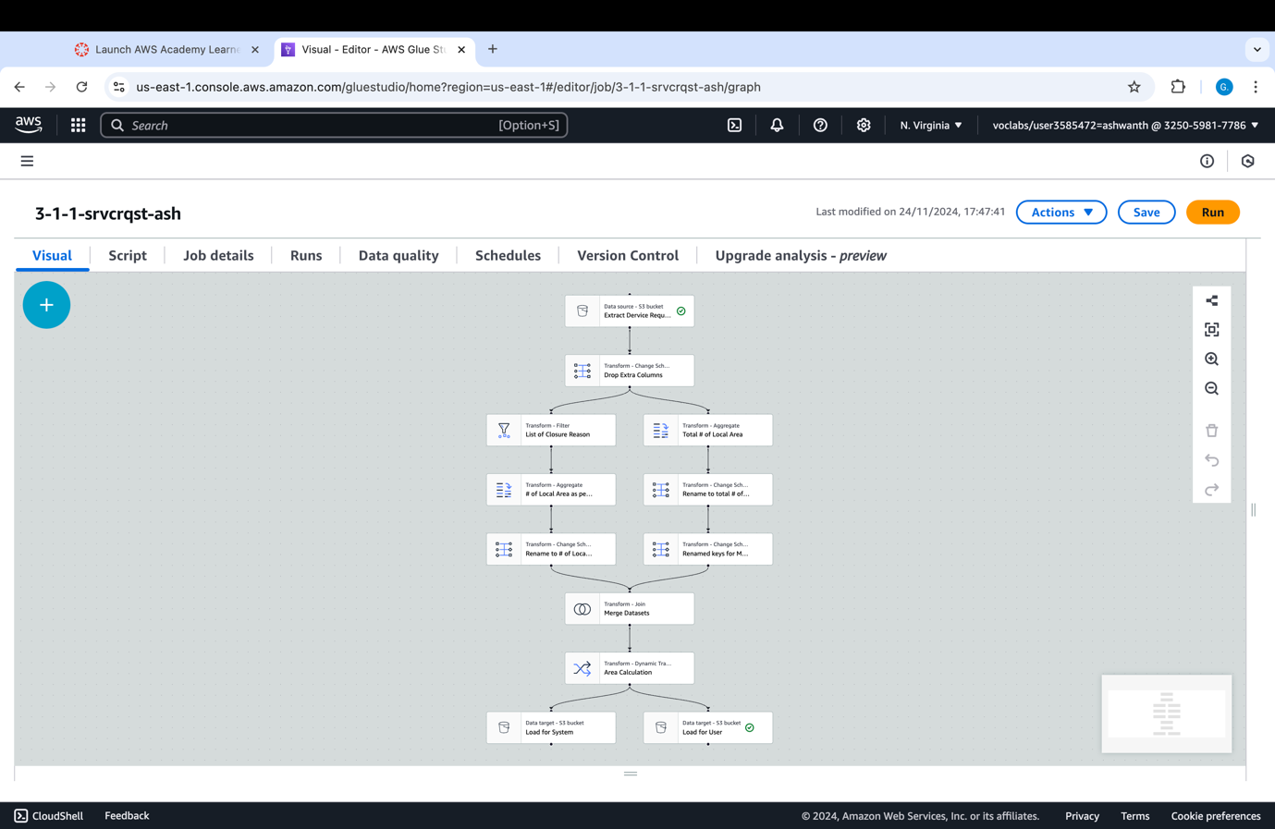

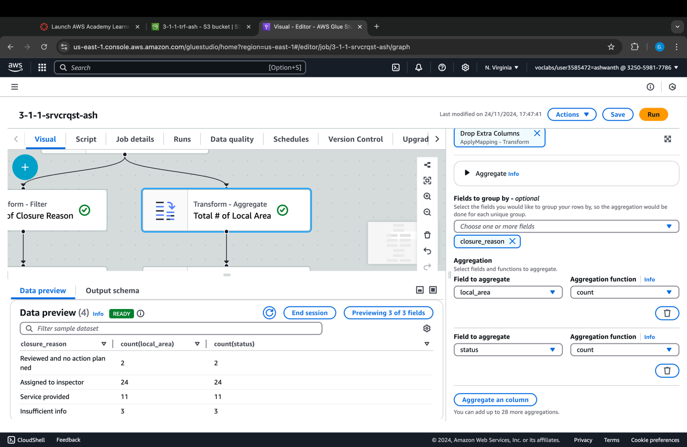

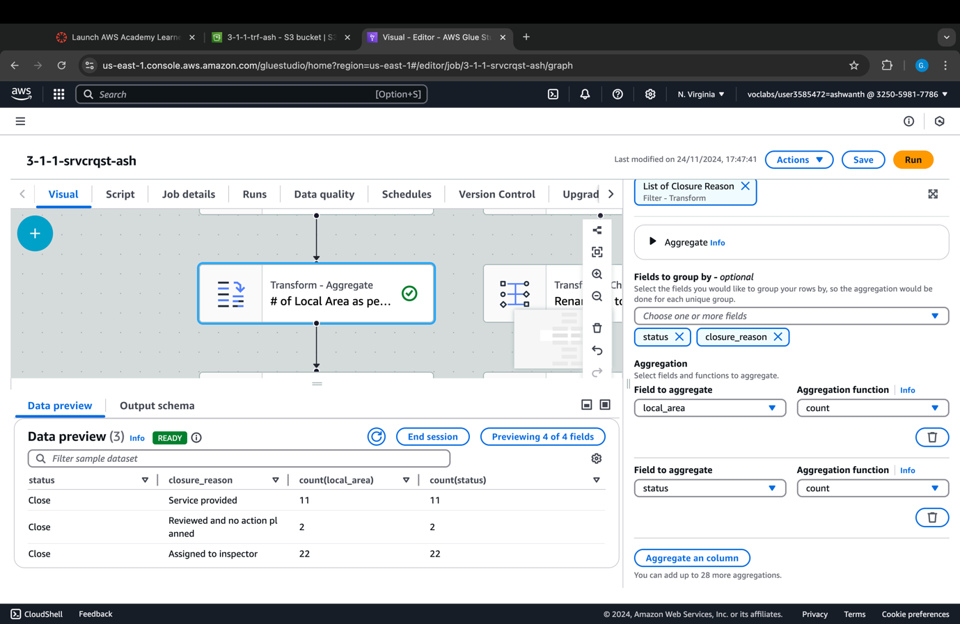

**DAP Cost Structure:**

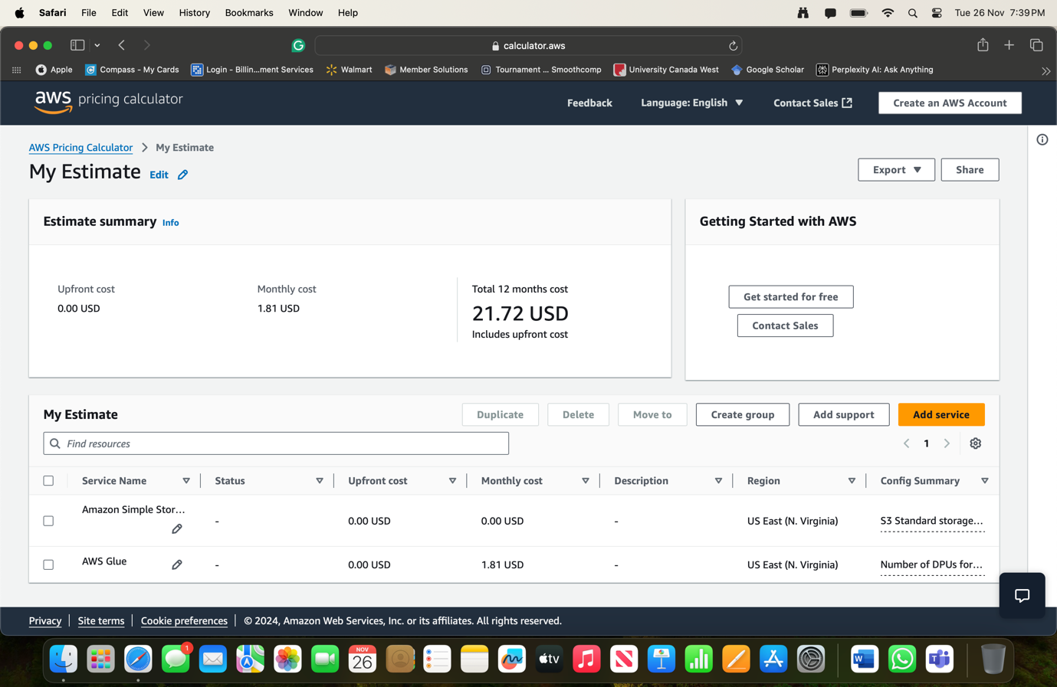

The benchmark of $21.72 per month for a year illustrates how various AWS services optimizing data ingestion, cleaning, profiling, and pipeline management were successfully used. The realized storage at Amazon S3 (Standard Storage) reflects the need for the storage of input and output data, which is another powerful element in the pipeline. Further, there is AWS Glue, which is a serverless data integration service that is used incurring zero DPUs and costs $1.81 monthly. This low cost is indicative of the arguably lean data operations, which are very likely to use highly efficient workflows or handle small-to-medium data loads.

## Step 5: Data Enriching

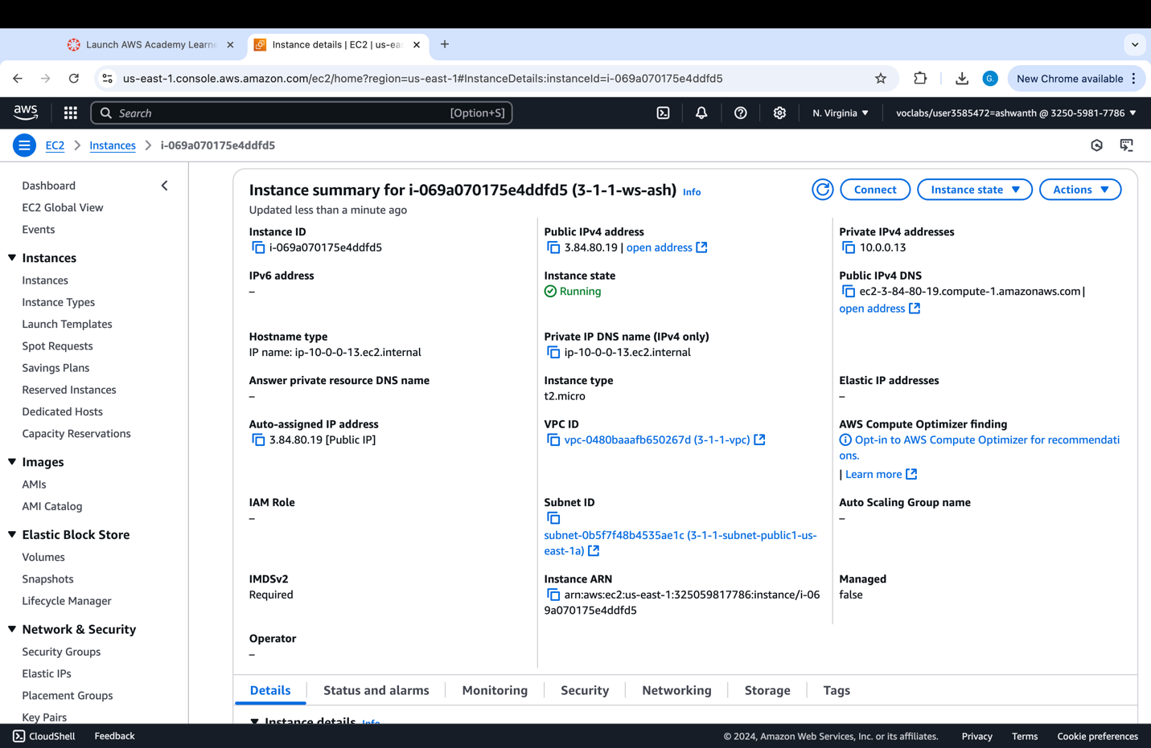

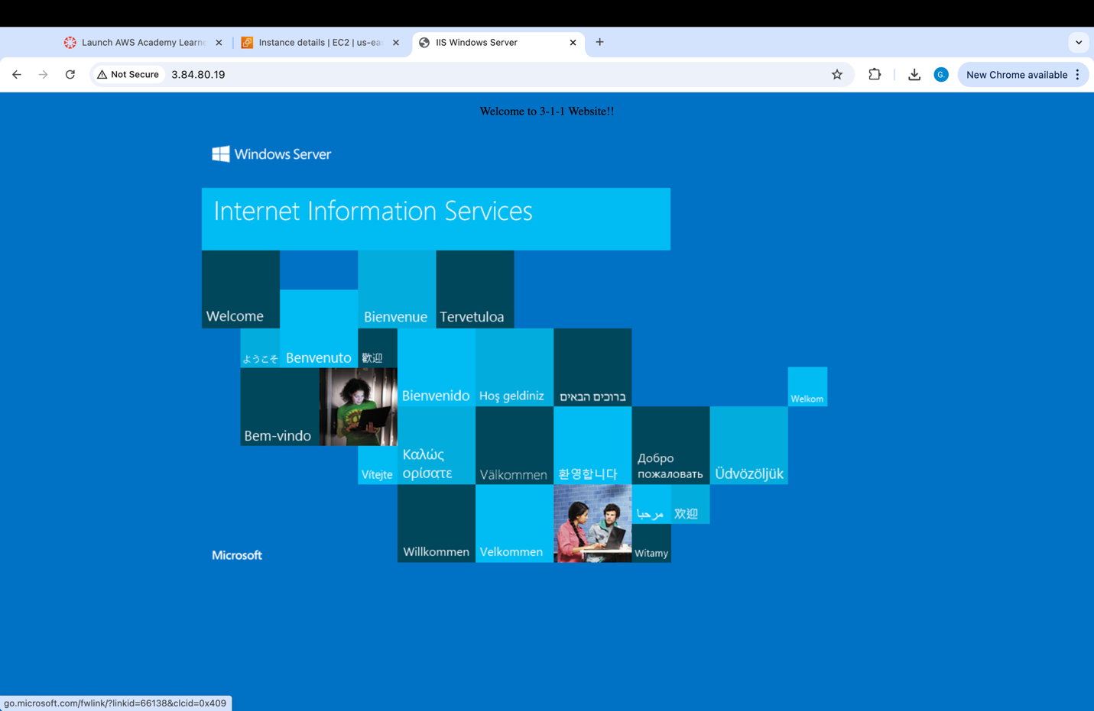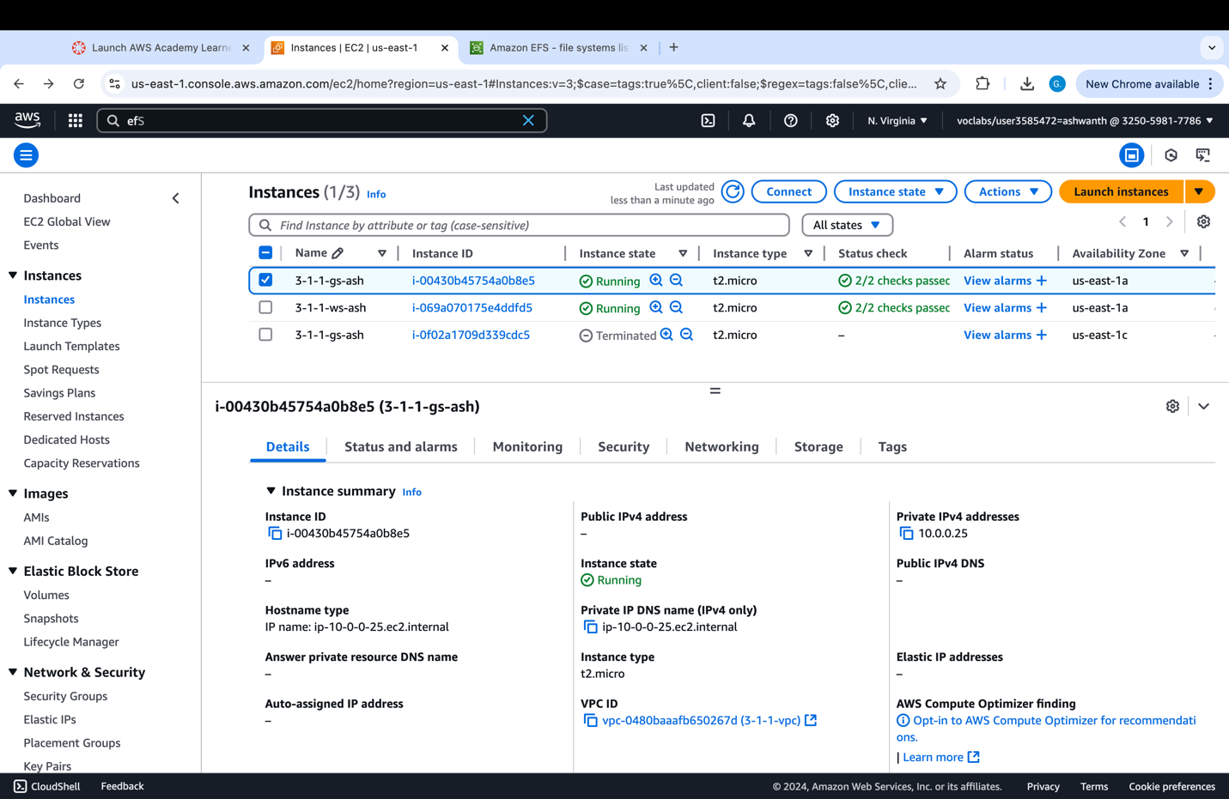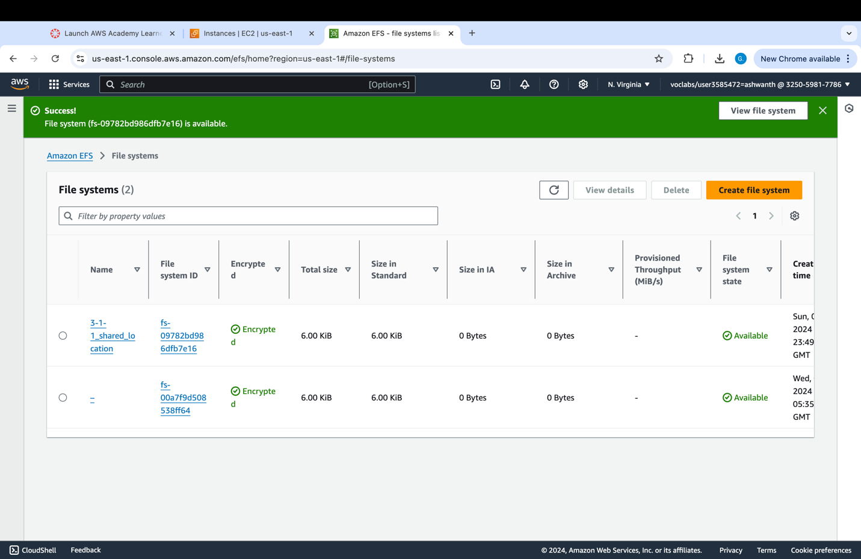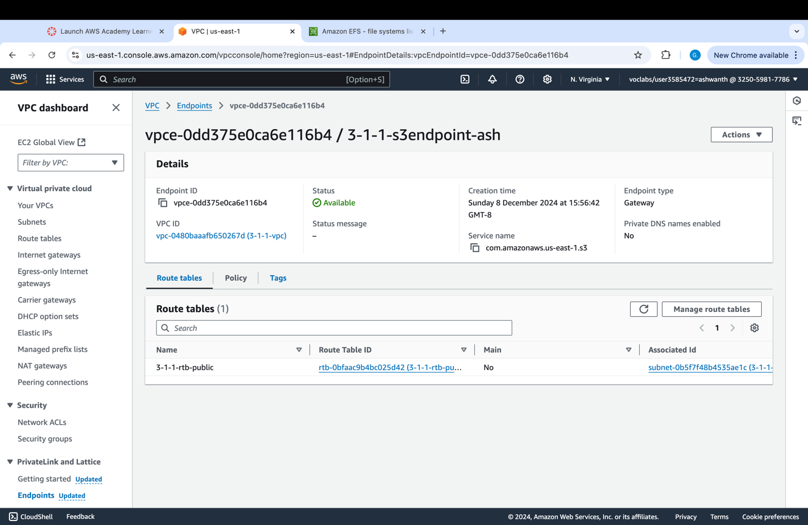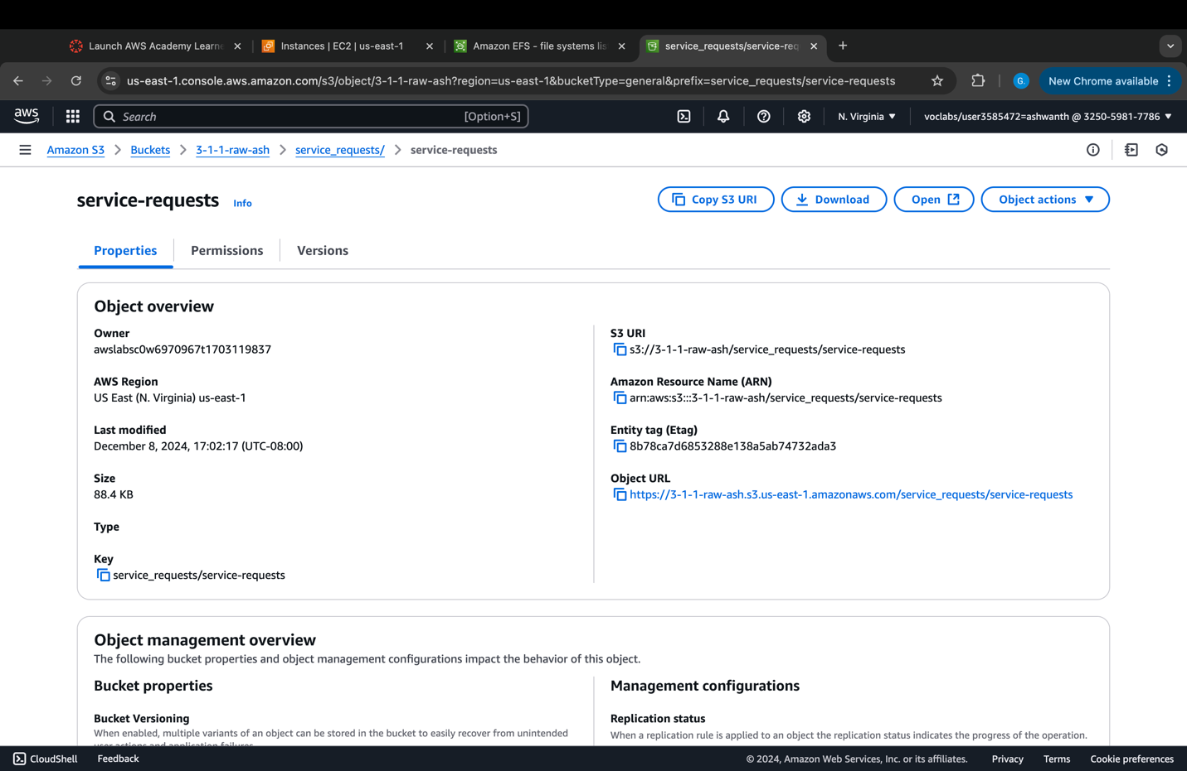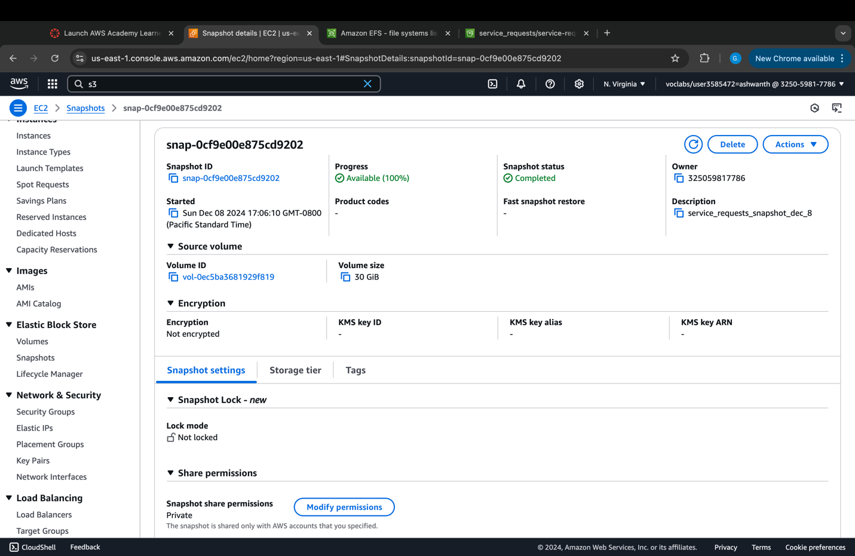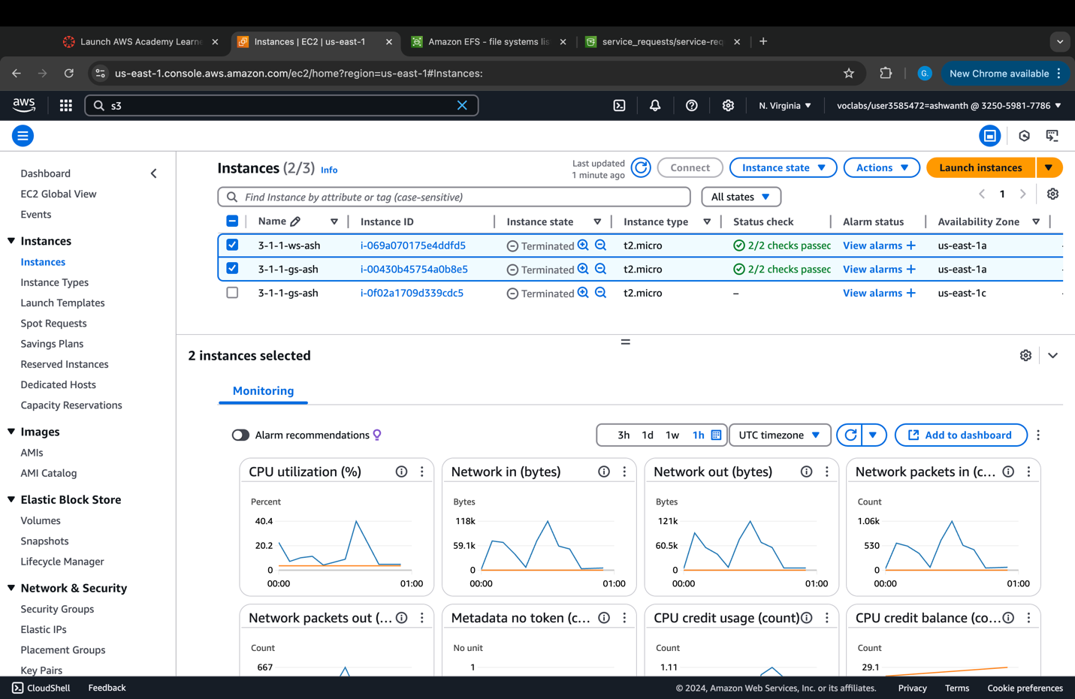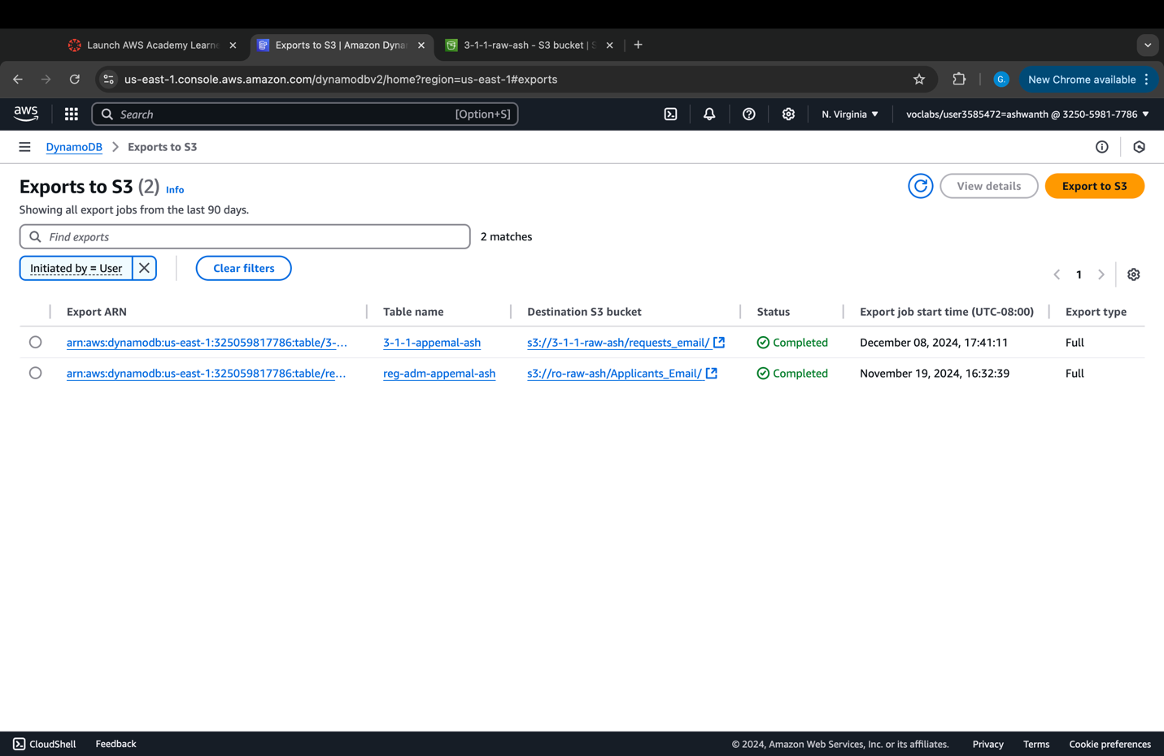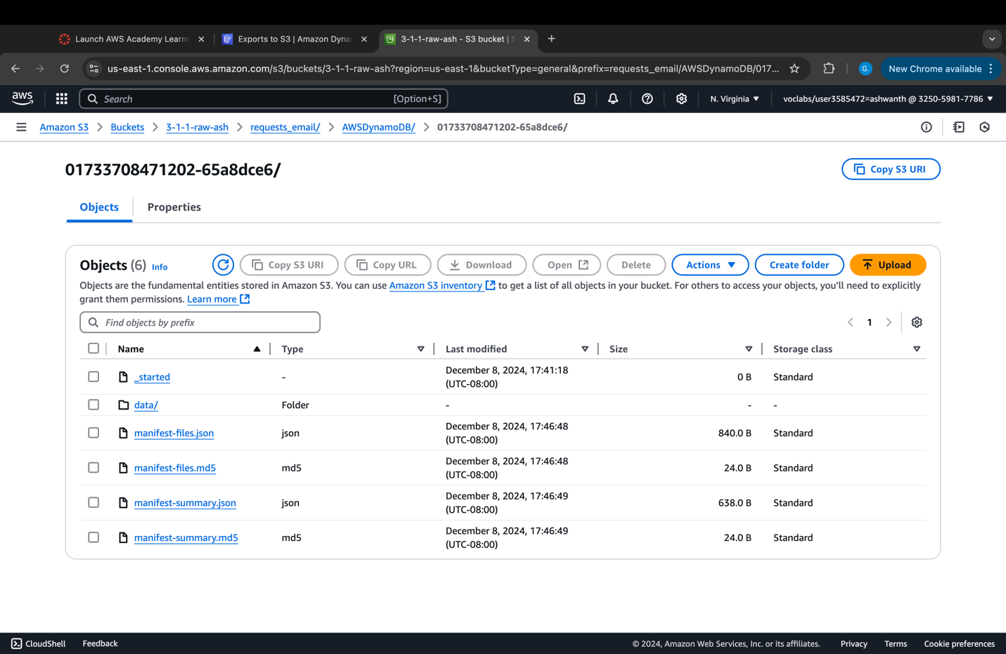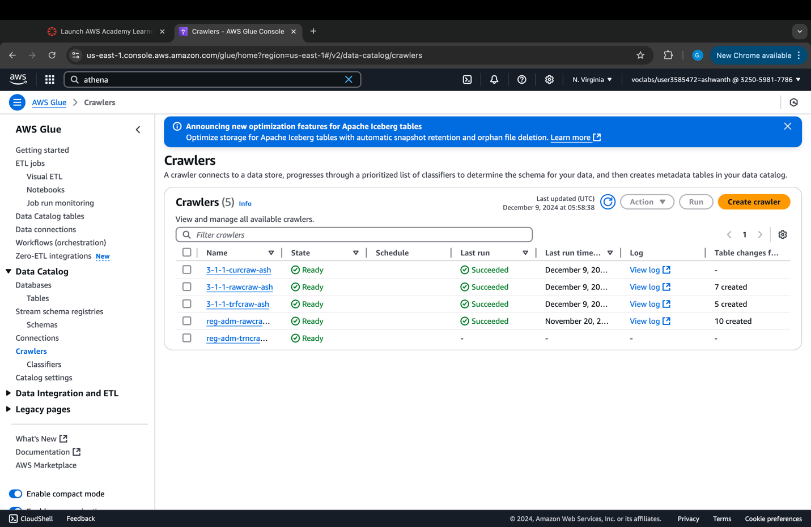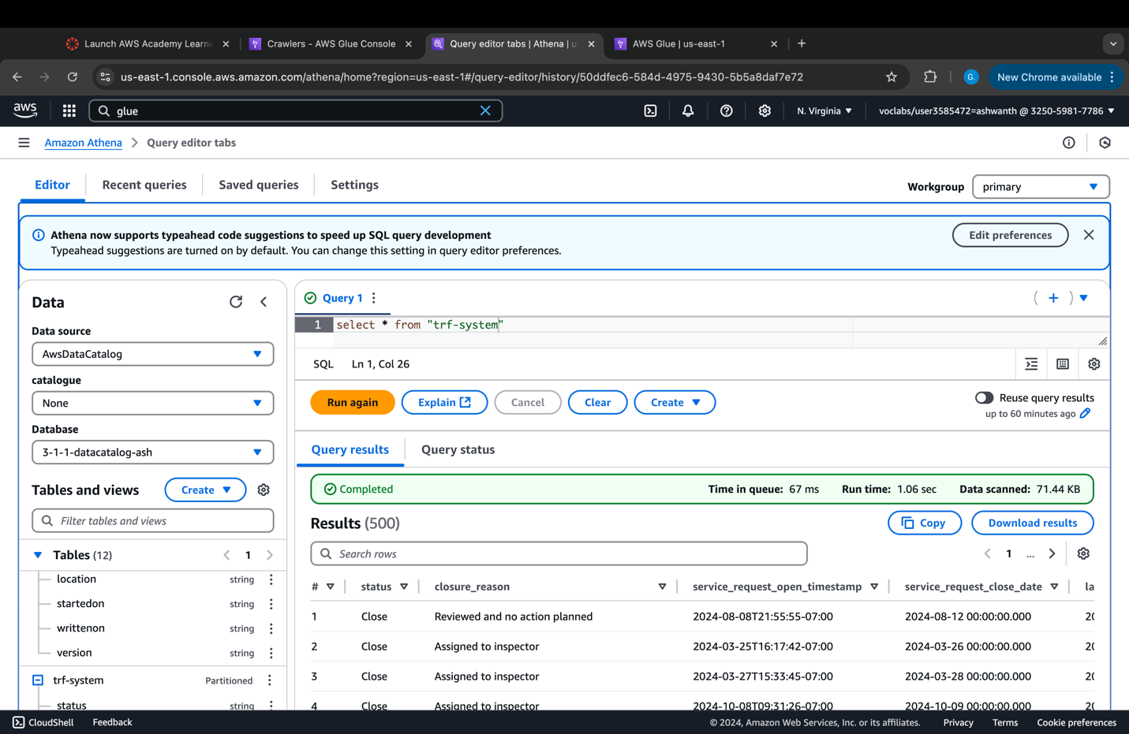

## Step 6: Data Protection

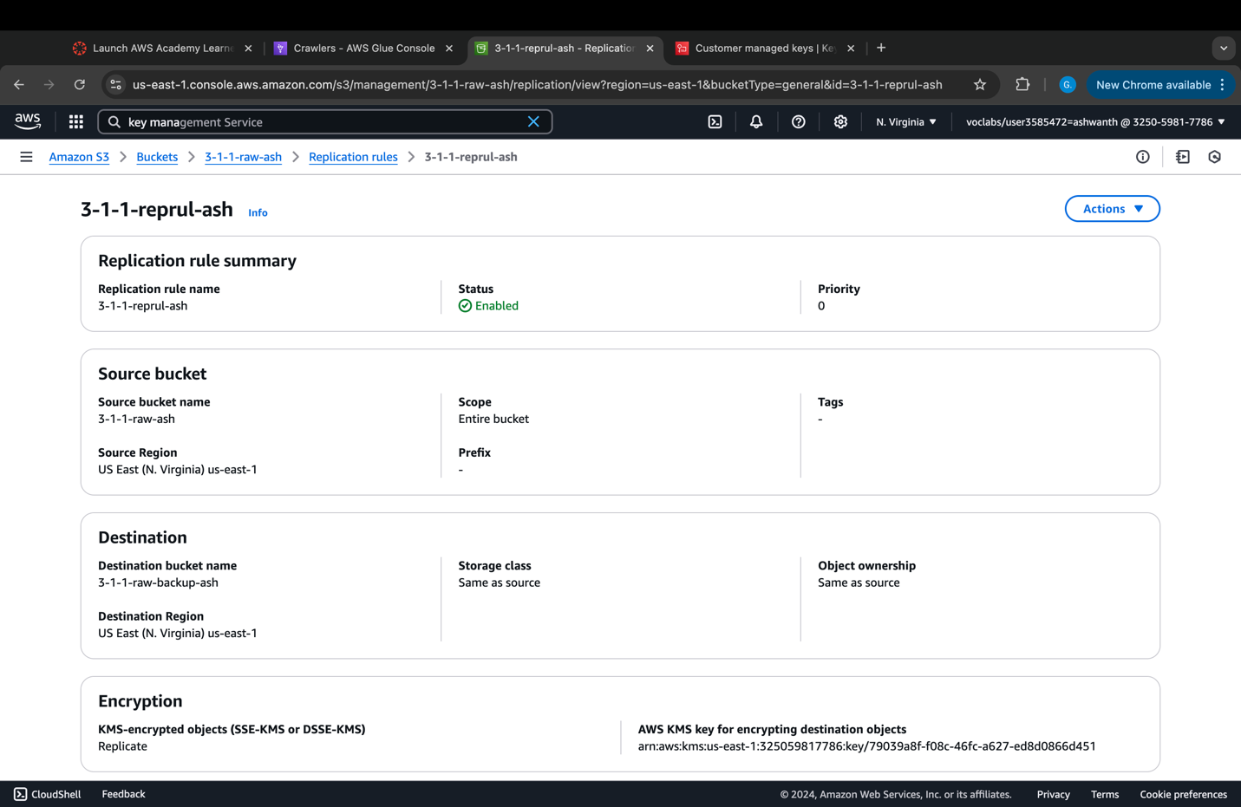

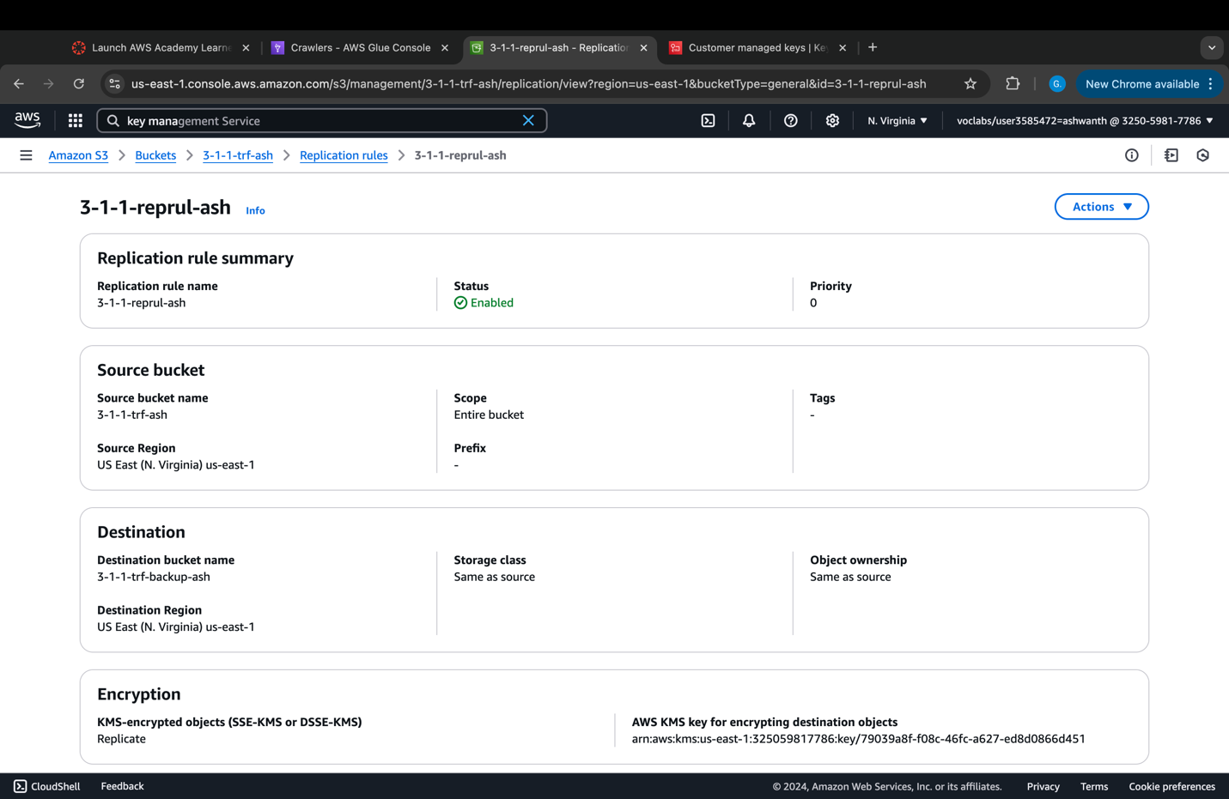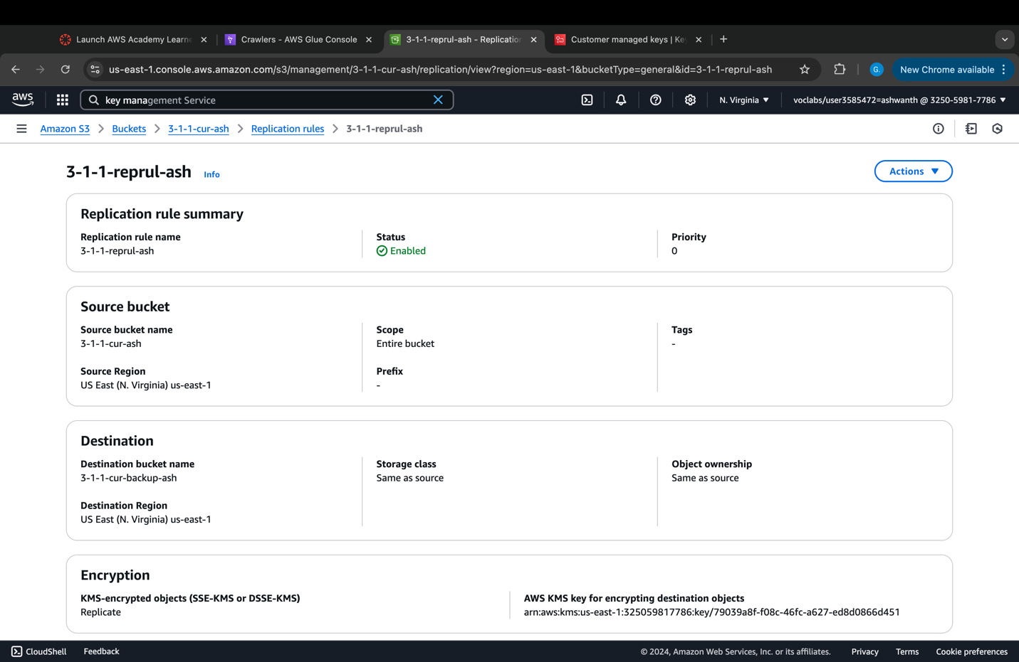

## Step 7: Data Governance

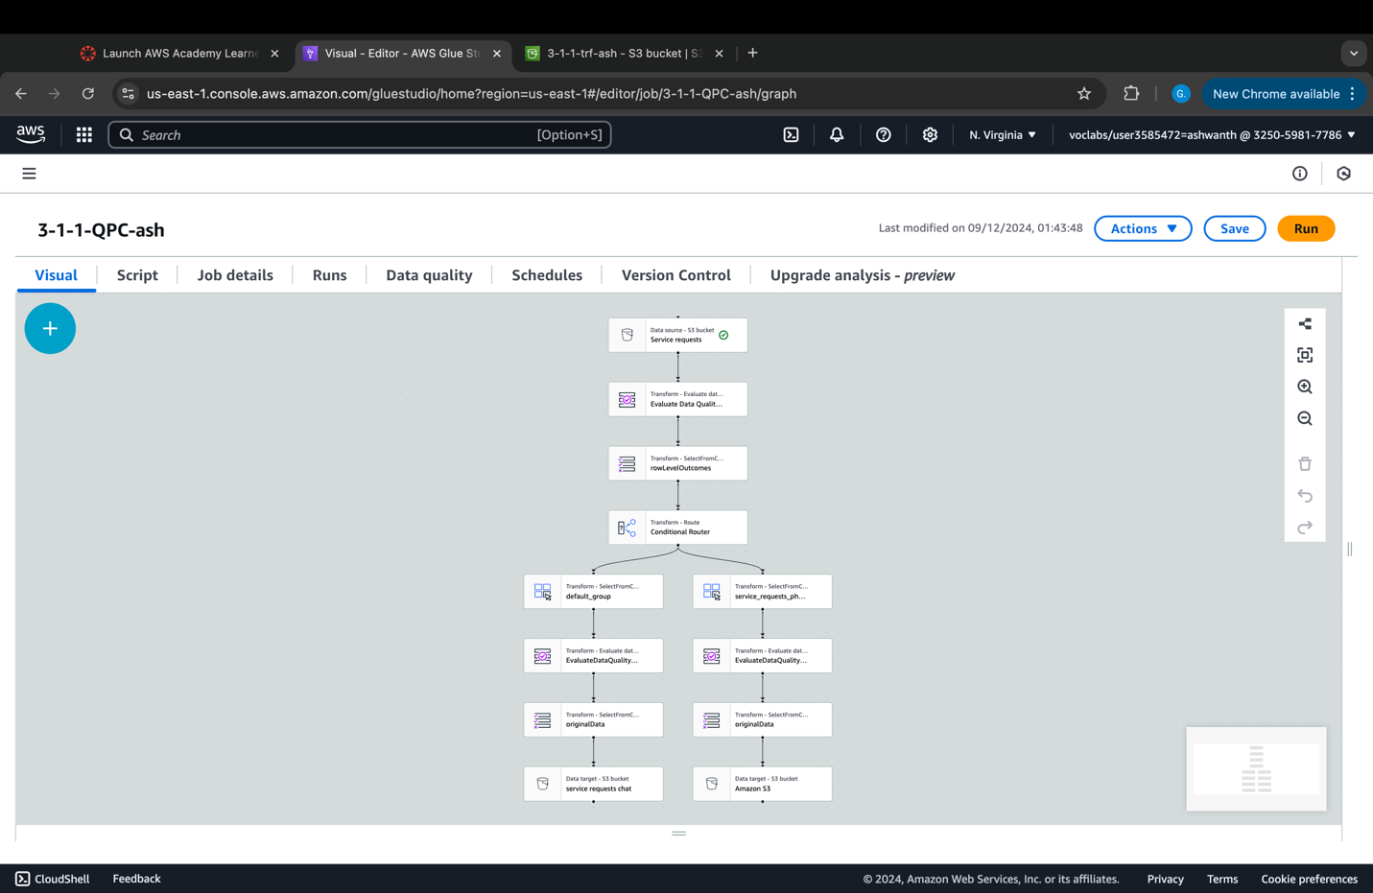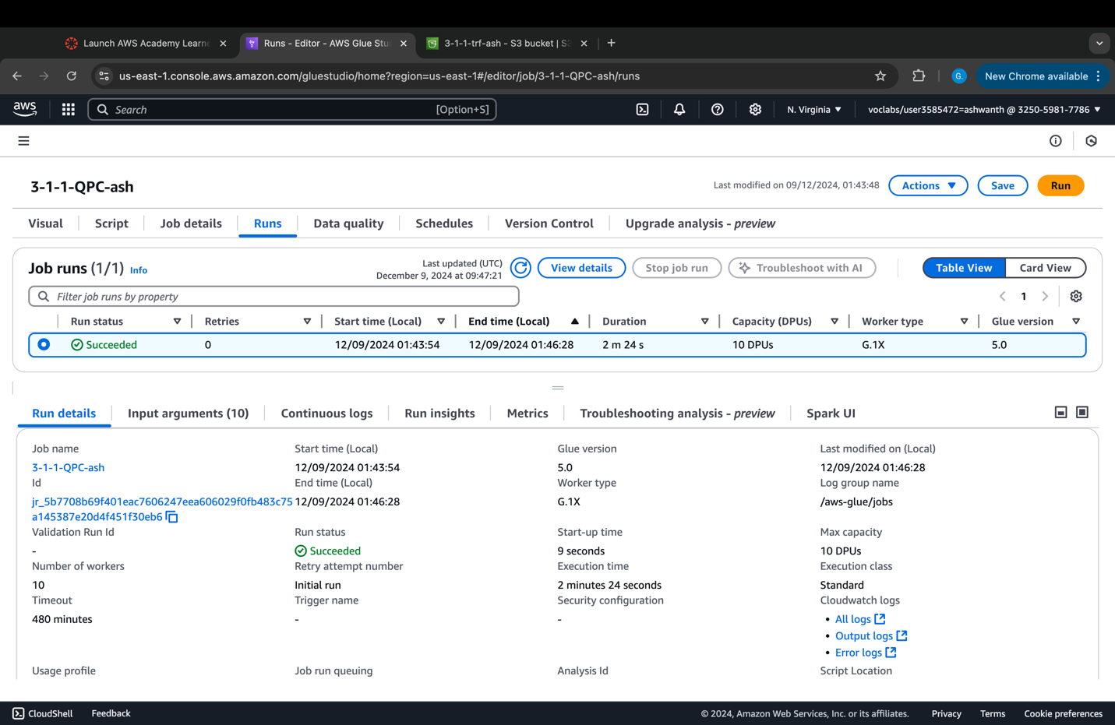

## Step 8: Data Observability

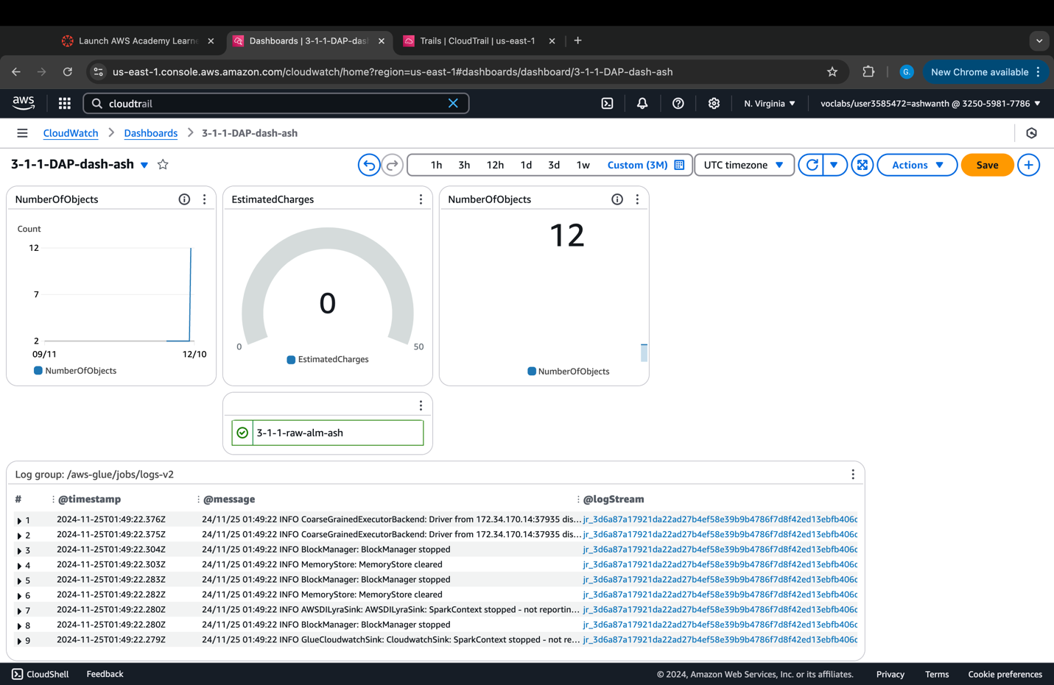

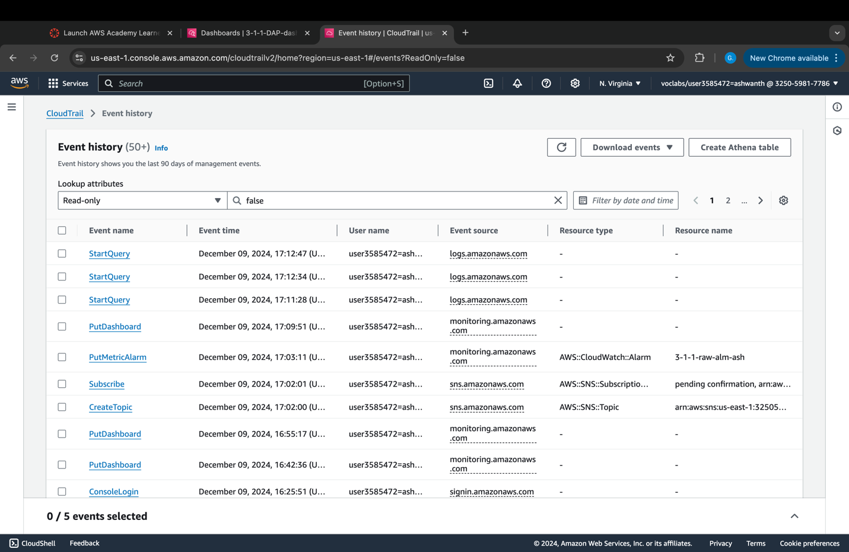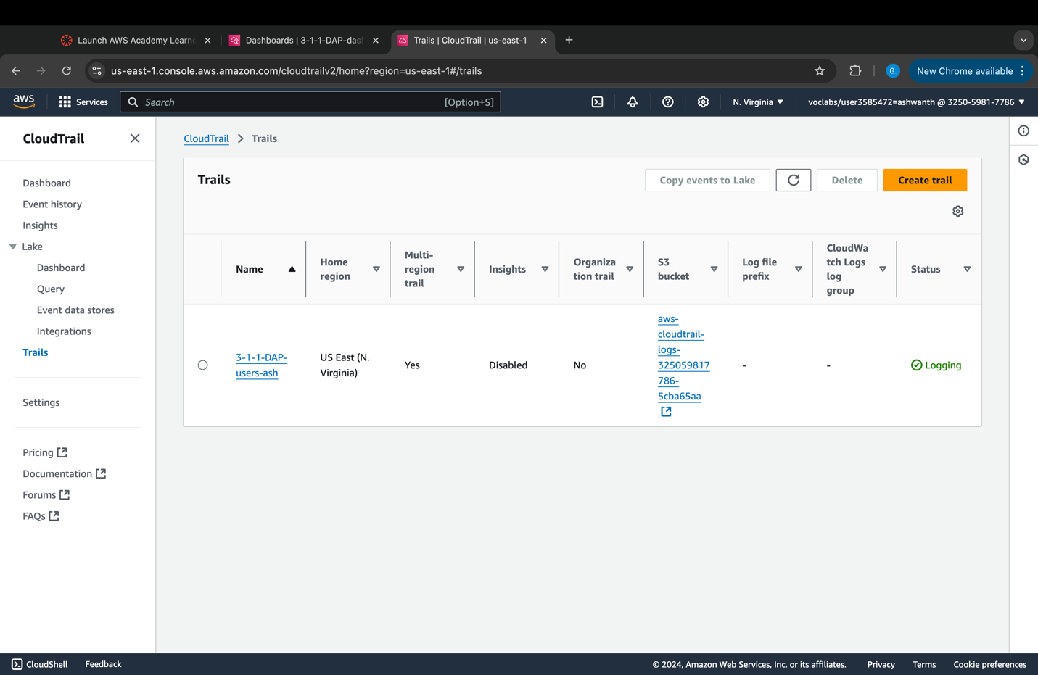

# DAP Architecture Analysis

## Operational Excellence

Amazon's extension of S3 data would enhance disaster recovery regions' capabilities. Can this be prioritized? Setting Up the implementation of automatic versioning backups for S3 buckets to prevent data loss and increase data recovery speed during disaster situations.

AWS Glue DataBrew is a powerful data exploration and cleaning tool that enables users to ingest, clean quickly, and profile data. The data quality rules established in DataBrew can identify and flag missing values, duplicates, and inconsistent data types, which helps address reliability concerns. Data cleaning and enrichment activities improve data quality, which in turn enhances the reliability of processes. downstream

AWS Glue can develop a solid data pipeline that guarantees that data is always processed correctly and without faults, thus contributing to the system's overall reliability. Extending data access across multiple regions can be prioritized in the next phase. Disaster recovery capabilities would be enhanced with the help of multi-region replication on Amazon S3. Backups should be scheduled automatically, and versioning should be turned on for all S3 buckets to prevent data loss and increase data recovery speed during incidents.

## Security

Keeping sensitive data like the street trees dataset secure is very important at every step of the data process. AWS provides powerful tools to ensure data safety during extraction, transformation, and analysis. For example, data stored in S3 buckets is encrypted either on the server-side (SSE) or client-side, with AWS Key Management Services (KMS) managing encryption keys securely. This ensures the data remains protected even in storage. Additionally, AWS Glue processes data and creates encrypted logs, which are safely stored in S3 and monitored through CloudWatch. CloudWatch helps keep track of these logs and performance metrics, allowing you to monitor the security and efficiency of your data pipeline.

AWS KMS plays a key role in managing encryption keys across Glue, DataBrew, and S3, ensuring that your data remains protected during each step. For added security, KMS also allows regular rotation of encryption keys, reducing the risk of unauthorized access. Together, AWS tools like Glue, DataBrew, S3, CloudWatch, and KMS work seamlessly to safeguard data and maintain the integrity and security of the entire data pipeline.

## Reliability

Amazon S3 provides highly dependable and durable storage, ensuring data availability and integrity across all services. By using AWS Glue Data Brew, the ingested data would be analyzed to understand its structure and quality, helping identify problems that might affect system reliability and removing inaccurate or incomplete data to enhance the dataset's overall quality. By creating a strong pipeline using AWS Glue, data processing reliability and durability can be guaranteed.

The part that can be covered in the next project is providing data access in several areas or regions. Multi-region replication on Amazon S3 will enhance disaster recovery capabilities. The setup of automatic backups and the setting of versioning in S3 buckets will prevent data loss in this situation, resulting in aiding and speeding up disaster recovery.

## Performance Efficiency

Data analytics pipeline (DAP) developed and deployed is proven to follow a highly efficient approach to attaining effectiveness in performance using an optimized combination of AWS services such as serverless approach and affordable trials. Data ingestion, cleaning, profiling and transformation tool AWS Glue is efficient in terms of resources because like many other serverless AWS services it scales depending on actual usage, which means no or minimal costs to pay for idle resources. The lack of DPU costs also characterize the optimal configuration, which in turn implies that the organization’s workflows were designed to efficiently process a given load, without incurring excess expenses.

The product to be stored must be horizontally scalable, repetitively reliable and offer very low operational overheads; That can be fulfilled by Amazon’s S3 used for data storage. S3 Standard Storage optimizes the difference between cost and performance which is inappropriate for one of the pipeline input and output datasets. The ability of the project to be cost-effective gives credit to the efficient workflows and MSF and small to medium data loads to support high performance without compromising the size and scale of the system.

There is potential for using other AWS options like caching options or segment computing options like Amazon CloudFront to minimize access time for information. Based on the findings of Module 9, there is a recommendation on increasing monitoring and scaling even more, and different mechanisms, such as Amazon AWS CloudWatch or AWS Auto Scaling in case of predictive scaling during high load of data. Such steps could serve to make the pipeline even more efficient and philanthropic for Vancouver city’s data handling.

## Cost Optimization

By charging based on resource utilization, AWS Glue, Data Brew, and Athena have decreased operating costs for cost efficiency. Additionally, using various Amazon S3 storage classes optimized costs by aligning storage types according to the data access frequency. Data cleaning, such as removing duplicate data or missing values, improves data quality. This aligns with the principle of measuring overall efficiency, as only high-quality data will be processed, reducing unnecessary costs. Implementing security measures such as encryption and backups using AWS KMS helps protect data and reduce security operational costs.

The area not covered in the project involves matching supply and demand to ensure that the scale of data ingestion aligns with business needs. Additionally, security and cost trade-offs need to be carefully considered, such as determining whether a high level of security is necessary for less sensitive data, which could lead to increased costs.

## Sustainability

Sustainability plays an important role in ‘green-city-goal-actionplan’ datasets while preparing and managing the data pipelines. This ensures that the process being used is efficient and effective from an environmental perspective. Here how sustainability plays an important role while using the AWS services such as Glue, DataBrew, S3, CloudWatch, KMS, and CloudTrail. The greencity data stored in S3 bucket which supports sustainable data storage with the option of S3 Glacier which helps to save energy by efficiently storing the less frequently accessed data. The AWS services like Glue and DataBrew adjust resources based on what we needed which helps to avoid waste and save energy. The CloudWatch service helps to resource optimization by monitoring the system performance which also gives information about the under and over utilized resources by generating logs and enabling energy saving. The AWS Key Management System (KMS) helps with the sustainability by handling the encryption key efficiently in both server and client-side encryption by reducing extra work on computers and ensuring the operation should be held security without excess resource usage. Lastly, Cloud Trail helps for auditing a monitoring purpose by integration with the CloudWatch logs and it helps to monitor and track the resource usage, operations optimization and reduce inefficiencies. These services support the AWS sustainability goals by encouraging green IT practices such as saving energy, using regions powered by renewable energy and by running computational tasks efficiently. By integrating these services, organizations can build secure, optimized and eco-friendly data pipelines which can support the sustainability goals and help to reduce the carbon footprints.